**NIMASA Says, Ill-Fated Boat; MV Sonny Not Nigerian Registered**

Article | March 22, 2013 - 9:38am

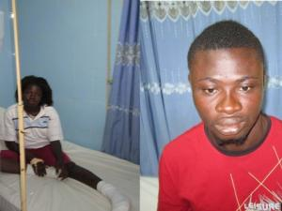

The Nigerian Maritime Administration and Safety Agency said yesterday that it has rescued 29 survivors after a wooden passenger boat identified as MV Sonny capsized 40 nautical miles offshore Calabar, Cross River State on its way to Gabon.  
The agency also cleared the air over the nationality of the passenger boat which took-in water and capsized on March 16. It says the boat is not flying Nigerian flag.  
The wooden craft which departed the Ebughu Jetty, Mbo Local Government Area in Akwa Ibom State capsized at about 2200 hours on the 16th March, 2013 reportedly ran into bad weather, leading to its capsizing.  
According to a statement issued yesterday and signed by its deputy director, public relations; Hajia Lami Tumaka, “the survivors who include eight Nigerians and 19 foreign nationals are undergoing medical examinations and further attention at Calabar and Oron based hospitals”.  
“Two survivors with severe burns are receiving medical attention at the Nigerian Maritime Academy Medical Centre, Oron, the survivors are Kareem Seradeke, a 20 year old male Burkinabe and, Adel Djanoka, a 24 year-old female Togolese.”  
Also receiving medical treatment at Calabar, Cross River State are two persons with varying degree of injuries.  
NIMASA , in the statement revealed further that, the ill-fated boat which had no manifest, however  had some unconfirmed number of passengers and crew on her voyage to Gabon.  
The wooden boat had called at a remote island off- Oron, Akwa Ibom state,  where passengers apparently embarked.  
According to the agency, preliminary rescue reports indicate that the survivors were rescued by a team of Addax Petroleum and Kaztec Engineering Limited who initiated on-site salvage of the passengers.  
Nine recovered bodies have been deposited at the Calabar Teaching Hospital.  
Information from one of the survivors confirmed that the incident occurred after the vessel hit an under-water object. This resulted in the boat taking-in water that led to eventual capsize of the boat.  
Another surviving passenger said the wooden boat departed the remote island off Oron under darkness to evade security agencies.  
The Agency commends the timely response of the Nigerian Immigration Service, Addax Petroleum and Kaztec Engineering Nigeria Limited in the rescue exercise.