NIGERIA UPDATE
25 JUNE – 8 JULY 2009

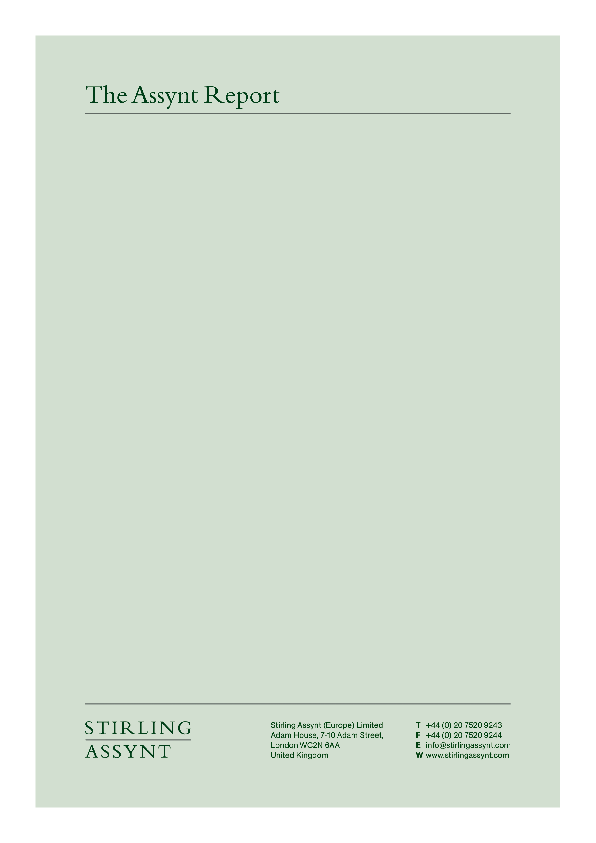

This document is provided on a confidential basis and for the sole use of the Client. Distribution in part or in whole outside the Client’s organisation is prohibited without the prior consent of Stirling Assynt. For further information, please write to info@stirlingassynt.com or call +44 (0) 20 7520 9347
NIGERIA UPDATE
25 JUNE – 8 JULY 2009

EXECUTIVE SUMMARY

NIGERIA

- President Umaru Yar’Adua proclaims August to October amnesty offer for Niger Delta militants, as violence and sabotage of oil facilities continues to spread across the region; oil companies confirm 20 percent of capacity lost since the Government’s May offensive; trial of Henry Okah, militant leader, is adjourned (p3).
- Nigeria, Niger, Algeria agree to build Trans-Sahara Gas Pipeline; Algerian Oil Minister Cheb Khelil says construction to commence in 2011 ahead of commissioning in 2015 – although Nigerian sources believe the project will take much longer to realise (p3).
- Nigeria establishes Joint Venture energy company with subsidiary of Russia’s Gazprom amid indications of divisions among officials over strategy towards Moscow (p4).
- Gunmen kill five police officers in failed attempt to kidnap expatriates near Aba in Abia State in South-East Nigeria; incident is an indication of security issues beyond Niger Delta and an increase in violent crime in recent weeks in several parts of the country (p5).

NIGERIA

Militants continue to strike oil industry targets across the Niger Delta despite official amnesty proclamation by President Yar’Adua

President Umaru Yar’Adua formally declared an amnesty for armed groups operating in oil-producing areas of the Niger Delta on 25 June. Mike Okiro, Inspector-General of Police, said on 6 July that the government was pleased with the response to the new initiative. However, several oil facilities have been sabotaged since the amnesty declaration (see below). According to the Nigerian National Petroleum Corporation (NNPC), 589,000 barrels/day (b/d) of oil, nearly a quarter of average daily production last year, has been lost since May alone. This shortfall is likely to have a significant – and destabilising - impact on government revenue.

The President said the amnesty would apply also to militants presently facing prosecution. This is understood to include Henry Okah, a leading official in the Movement for the Emancipation of the Niger Delta (MEND, an umbrella organisation for several armed groups in Nigeria’s oil producing area). Okah was arrested in Angola in 2007 and deported to face charges of treason and conspiracy. His trial resumed in the central city of Jos on 3 July but was immediately adjourned to mid-July.

MEND appeared to reject the amnesty in a statement on 26 June: “Only those who are willing to sell their birthright for a bowl of porridge will accept while the rest of us will continue the struggle until justice is achieved.” However, MEND has a history of inconsistent statements. Several prominent warlords are understood to be considering the offer, including Henry Okah. In subsequent emails to the international media, MEND has indicated it would consider dialogue with the government. In the meantime, attacks have continued. On 6 July the Joint Task Force confirmed the sabotage of a Chevron pipeline in Delta State, a Shell oil well head in Rivers State and the kidnap of tanker crew.

The amnesty expires on 4 October. Security sources say they do not expect full compliance with the amnesty. The aim is to co-opt some groups, who stand to benefit from access to a N4 billion ‘demobilisation’ fund, and to isolate others, allowing time for the military to strengthen logistics and regroup ahead of a renewed offensive after the end of the rainy season. The longer-term success of such tactics will, however, depend on the capacity of the government to generate legitimacy and credibility for the state in Nigeria’s most impoverished and lawless region. Such a strategy will require substantial resources and a display of leadership, accountability and transparency hitherto not present in the Delta.

Back to top

Algeria and Nigeria commit to Trans Sahara Gas Pipeline project

On 3 July Nigeria, Algeria and Niger signed an agreement to construct a USD 13 billion pipeline to send gas from the Niger Delta across the Sahara to the Mediterranean and on to markets in Southern Europe. Algeria’s Oil Minister, Cheb Khelil, said he envisaged no difficulties raising finance for the project or in related technical issues. He anticipated construction work to begin in 2011 and for the pipeline to be commissioned four years later. Shell, Total and Gazprom have publicly indicated interest in the project, as have other companies. There is, however, some scepticism in the industry and in government in Nigeria over the timetable indicated by Mr Khelil.

Nigerian officials note there are security issues to resolve in the Niger Delta, in Northern Niger and Southern Algeria; and commercial issues relating to the sourcing of gas from concessions already licensed to international oil companies. According to a well-connected source in government, “this project has been on the drawing board for 30 years. We are absolutely committed to the pipeline, which will be a huge asset for us. But we cannot underestimate the obstacles we must pass. It will happen, but perhaps not as quickly as everyone might wish.”

The European Union has backed the proposed pipeline, which could supply 30 billion cubic metres of gas a year to a market anxious to diversify from an uncomfortable dependence on Russia. However, Gazprom of Russia is one of the companies that has expressed interest in the project, a prospect that Nigerian officials say they hope to leverage in negotiations with rival European or American companies looking to participate in the project.

Back to top

CBN Governor supports relaxation of bank ownership regulations

The Joint Venture between Russia’s Gazprom and the NNPC, agreed on 24 June during the visit to Abuja of Russia’s President Dimitry Medvedev, is to be called NiGaz Energy Company Ltd. The new company is to consider investments in: gas exploration and production; processing, transportation and marketing; infrastructure development; pipeline construction; power development; training and capacity building. The two sides have not, however, agreed an ownership structure for NiGaz, a Board of Directors or a management team.

The relationship between Nigeria and Gazprom remains controversial, According to a senior Petroleum Resources ministry source in Abuja, “What we have done is to sign a JV not with Gazprom but with Gazprom’s Dutch subsidiary. That is a rather impudent position on the part of the Russians. This has been done in too much of a hurry with too little thought. We are reserving the right to modify these arrangements.” Several key officials in Nigeria are wary of developing relations with Gazprom that might result in Nigeria being used by Russia to strengthen its position in global – and in particular European – markets, to which Nigeria is seeking access.

Other officials believe, however, that Gazprom can be used as leverage to encourage concessions from rival international oil companies operating in Nigeria. Relations with such companies are presently strained, amid differences over reforms proposed as part of the Petroleum Industry Bill before the National Assembly. According to a presidency source, Nigeria would prefer to maintain its established relationships – but is ready to pursue interest from Russia and Asian countries more rapidly to develop its gas potential.

Back to top

Gunmen kill five policemen during failed Abia State kidnap attempt

Five policemen were killed on 1 July in a botched attempt by an armed gang to kidnap expatriate workers at a bottling plant near Aba in Abia State in South East Nigeria. Police said gunmen ambushed a convoy, prompting a gun battle after which the gunmen fled. No arrests were made and no group has claimed responsibility for an attack that appears to have had no political motivation. Security sources say there has been a sharp increase in violent crime in the region in recent weeks, which is unrelated to instability in the Niger Delta – but an indication of systemic law and order and governance issues in several parts of Nigeria.

Back to top

