NIGERIA UPDATE
2 - 24 APRIL 2009

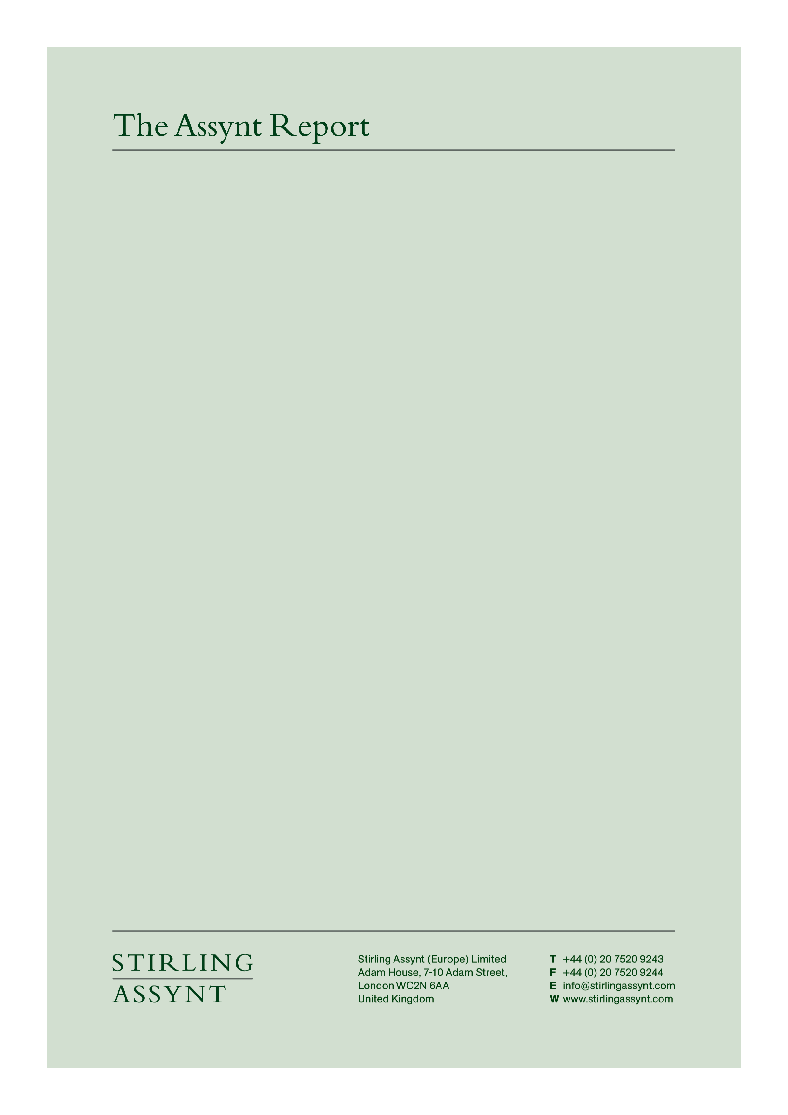

This document is provided on a confidential basis and for the sole use of the Client. Distribution in part or in whole outside the Client’s organisation is prohibited without the prior consent of Stirling Assynt. For further information, please write to info@stirlingassynt.com or call +44 (0) 20 7520 9347
NIGERIA UPDATE
2 - 24 APRIL 2009

EXECUTIVE SUMMARY

NIGERIA

- US issues alert over threat to diplomatic missions in Lagos, but Government dismisses it as unfounded, Niger Delta militants say there are no plans to target diplomatic facilities; episode reflects US, UK concern over Nigeria’s vulnerability to international terror, despite the absence of strong local Islamist movement (p3).
- Niger Delta militants reject government offer of amnesty, violence continues; British national abducted in September released, militant leader treason trial resumes; beyond Delta region, gunmen kidnap Canadian national in North, although Italian national released in East (p3).
- President Yar’Adua sidelines predecessor at ruling party Convention; renews commitment to electoral reform, urges improved governance in Nigeria’s states and seeks to reduce politicking ahead of 2011 elections (p4).
- Anti-corruption officials pledge to pursue former Governors charged with impropriety; other high profile cases amid criticism of diminished enthusiasm to combat prevalent culture of graft (p5).
- Vice-President talks up investment opportunities, prospects for recovery, although problems remain; Presidential commission proposes USD 500 million stimulus package; inflation falls slightly, pressure on naira continues (p5).

NIGERIA

Unfounded US fears of terror attack provoke angry response from Government, denials from Delta militants

On 5 April the American Embassy in Nigeria issued a public warning to US nationals of a security threat against diplomatic missions located nears its consulate in the Victoria Island district of Lagos, the main commercial centre. The US gave no further details although security sources indicate the decision to issue a public warning followed intelligence of an Islamist attack against one of the consulates of a main Western power situated on Walter Carrington Crescent.

The Movement for the Emancipation of the Niger Delta (MEND, an umbrella organisation that says it speaks for several armed groups in Nigeria’s volatile oil producing region) disassociated itself from the threat of violence. MEND said it “abhors acts of terrorism and wanton destruction of life and property” and had no quarrel with the people of America. The US statement also drew an angry response from the Government. Information Minister Dora Akunyili said there was “no critical threat in the form of any immediate terrorist attack at this time," and complained that the reported threat gave a “false picture” of the security situation.

The subsequent absence of any attack appears to have vindicated Ms Akunyili’s position. However, Western intelligence officials continue to express concern over the potential vulnerability of assets in Nigeria to a terror attack. In 2007 the US and UK received intelligence of a planned attack on assets in Abuja, which also proved unfounded. Security sources acknowledge the broadly conservative nature of Nigeria’s Muslim community – around half a total population usually estimated at around 140 million – but maintain there are radicalised elements also in addition to a significant, established Lebanese and Pakistani community.

Back to top

Niger Delta militants reject amnesty but release hostage

On 2 April President Umaru Yar’Adua offered a conditional amnesty to militants in the Niger Delta who were willing to surrender their arms and ammunition. While officials have tried to portray the move as a conciliatory gesture, it essentially confirms the Government’s central position that armed groups use populist rhetoric to mask a criminal and extortionist agenda. MEND rejected the offer within 24 hours. In a statement, it said it doubted the government’s sincerity and called for international mediation as the cornerstone of any genuine peace process. In the same statement, the group also acknowledged the existence of internal divisions within the movement, although it claimed these “had been put aside to face a common enemy.”

Despite the defiant rhetoric, militants have sent mixed signals in response to the President’s initiative. Around 20 gunmen have been killed in clashes with the Joint Task Force this month and attacks on oil facilities in Bayelsa and Rivers States – although more production was lost from a 12 April fire and technical failure on a Shell pipeline than from militant activity. Indeed, industry analysts have argued for some time that the precarious financing of joint ventures between international oil companies and the cash-strapped Nigerian National Petroleum Corporation represents a more serious threat to the long-term prospects for the oil industry in Nigeria than the security environment.

On 5 April gunmen kidnapped a British oil worker in Port Harcourt, capital of Rivers State and centre of the oil industry in the Eastern Niger Delta; two of his Police escorts were shot. In a separate incident on the same day, a security consultant was shot dead and a Nigerian manager of a local aluminium company was abducted. Gunmen also attacked a Korean facility in neighbouring Bayelsa State. On 21 April gunmen attacked an oil tanker and seized some of its Turkish crew – confirming the piracy issues that make the Gulf of Guinea more vulnerable even than the volatile seas off Somalia.

In a more conciliatory move, on 19 April gunmen released Robin Hughes, a British oil worker kidnapped last September. Abductions in Nigeria are typically resolved in days after a ransom is quietly paid; MEND said it was holding Hughes and another hostage Matthew Maguire as leverage in a bid to extract concessions ahead of the trial of Henry Okah, an alleged arms dealer and oil smuggler with links to MEND who faces a range of charges, including treason. His case resumed in the central city of Jos on 7 April. It is unclear what deal was done to secure Hughes’ release – although militants said earlier in the year one of the British hostages was in poor health, and they may have been keen to avoid his death while in their custody and the backlash it might have provoked.

The Niger Delta is widely regarded as the main security challenge to businesses looking to operate in the region. However, a series of incidents elsewhere indicate security remains a serious issue in several parts of the country. While armed robbery is relatively common in most of the country’s major cities, on 6 April an Italian national was kidnapped – and later released - in Eboniyi, in the East; on 16 April gunmen abducted a Canadian woman in Kaduna in the North; and on 20 April gunmen were reported to have shot dead at least 30 people and injured many others during a bullion van robbery near Onitsha, also in the East. Such incidents confirm the prevalence of armed violence unrelated to any overt political agenda, and the security forces’ limited response capacity.

Back to top

Yar’Adua moves against Obasanjo as PDP eyes 2011 elections

Supporters of President Yar’Adua secured a significant victory over his predecessor Olusegun Obasanjo at the convention of the ruling People’s Democratic Party in Abuja on 20 April. Before leaving office, Obasanjo had introduced measures that effectively gave him a position of permanent influence in the party as Chairman of its Board of Trustees. Many of those measures have now been repealed, leaving the former President with a much diminished platform as the party begins to gear up for a process of selecting candidates for state and national elections in 2011. Obasanjo is understood to be furious at the move, telling aides that he will use remaining resources at his disposal to battle Yar’Adua, with whom he has had a difficult relationship since their 2007 handover.

While the internal party reforms have been widely regarded as a move against Obasanjo ahead of a re-election campaign by Yar’Adua, the President used the Convention to warn State Governors to remain focused on governance issues rather than electioneering. Yar’Adua, however, appears to be doing both: he has set as a priority the doubling of power generation supply to 6,000 MW by the end of 2009, but within a structure that could see capital diverted towards an election fund. Sources close to the Presidency are also floating the possibility of a break with some of his wealthier but politically less palatable supporters, including James Ibori, the former Governor of Delta State, charged in 2007 with 150 counts of corruption and wanted in the UK in connection with money laundering allegations.

Back to top

Critics unconvinced by anti-corruption pledge

The Economic and Financial Crimes Commission, Nigeria’s principal anti-corruption agency, remains committed to the prosecution of politically well-connected former office holders and rejects allegations that it has lost its way in recent months, according to Farida Waziri, appointed chair of the EFCC in June 2008. Speaking at celebrations on 16 April to mark the 6th anniversary of the establishment of the Commission, Mrs Waziri said she would continue to pursue those guilty of corruption, and that accusations to the contrary were politically motivated by those who themselves had something to hide.

She said Nigeria would seek the extradition from the US of Nasir El Rufai, former Federal Capital Territory minister (2003-07) and architect of a well regarded economic reform programme. She added that investigations would continue over the Nigerian operations of subsidiaries of Siemens and Halliburton, companies that have pleaded guilty in the US to bribing Government officials in Nigeria. On 23 April, the EFCC charged the Chairman and Chief Executive Officer along with other officials of the Nigerian Electricity Regulatory Commission (NERC) with 196 counts of impropriety involving the equivalent of more than USD 30 million. However, police sources in Nigeria maintain Mrs Waziri has limited room for manoeuvre and is obliged to follow an agenda effectively set by Michael Aondoakaa, the Attorney General, who has a colourful and controversial reputation but appears for the moment to enjoy the full confidence of the Presidency.

Back to top

Vice-President talks up Nigeria’s economic potential

Goodluck Jonathan, Nigeria’s Vice-President, has warned companies who hesitate before engaging the Nigerian market that they risk missing out on the massive opportunities he said the country had to offer. Speaking at a conference in London on 22 April, he said the Yar’Adua administration was taking “drastic measures” to rebuild infrastructure and introduce other investor-friendly policies as part of a long term strategy to make Nigeria one of the world’s top 20 economies by 2020. At the same conference, however, Deputy Finance Minister Remi Babaloa acknowledged the economy was performing far below the 2009 budget estimates for growth of 8.9 % and 8.2 % inflation; March inflation figures fell slightly to 14.4 % from 14.6 % in February.

President Yar’Adua has established several advisory committees to meet the challenge of the global economic slowdown. Babalola said the government was considering a proposal for a USD 500 million stimulus package funded from the Excess Crude Account, established in 2003 to save surplus earnings from oil but presently the subject of a legal challenge from some States that argue the Account is unconstitutional (see last report). Details of the package are unclear, but it is unlikely to mitigate to any real extent the impact of the sharp fall and continuing uncertainty of the price of oil, which provides 95 % of Nigeria’s export revenue.

Back to top

