**12 killed, 13 arrested as explosion rocks Borno, again**

[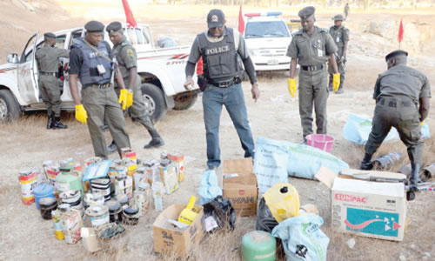](http://newsnaija.org/?attachment_id=737)AT least 12 people were said to have been killed and a school burnt in Maiduguri, the Borno State capital, in a renewed violence and attacks in three separate areas of the state.

This is just as gunmen, suspected to be members of the Islamic militant, Boko Haram, slaughtered five people in Jiddari Polo, with another five killed at another place, while soldiers claimed to have killed two members of the sect during an exchange of gunfire.

Nigerian Tribune learnt that at about 10.00 p.m on Tuesday, gunmen, in large number, stormed some houses at Polo Jiddari ward of Maiduguri, where they slaughtered five people.

It was also learnt that another set of the attackers killed four people in London Ciki area and one person at Baga Road, at about 5.00 p.m.

A resident of Federal Low Cost Housing Estate, who preferred anonymity, told Nigerian Tribune that three abandoned Volkswagen Golf car and three Keke NAPEP belonging to the gunmen were burnt by soldiers, who pursued them into a house where they took cover.

“Nobody knows the number of gunmen or the people killed in the raid on the house where the gunmen took cover, but we believe many people, perhaps innocent ones, might have been trapped in the houses while the soldiers bombarded the house with gunfire. Many, we believed, have died,” he said.

However, in a release on the incident, the Joint task Force on Operation Restore Order in Borno State said “some suspected gunmen killed three people at about 3.00 a.m today (Wednesday) in Jiddari-Pulo, Maiduguri metropolis.

“The JTF was alerted; it cordoned off the area, arrested three suspects and recovered one assault rifle with 10 rounds of ammunition. Two gunmen lost their lives and a soldier was wounded during an exchange of fire. The suspects are in JTF custody and effort is on to apprehend the fleeing members of the gang.”

In another development, gunmen were said to have attacked Binta Sugar area of Maiduguri and burnt down Gomari II Primary School in the area at about 7.00 p.m on Tuesday.

Also, at about 11.00 a.m, violence erupted at Shehuri ward of Maiduguri, following a bomb blast, which was believed to have been planted by suspected members of Boko Haram insurgents.

Spokesman of the JTF, Lieutenant-Colonel Sagir Musa, confirmed the development, adding that though no life was lost, the security outfit was able to arrest 10 suspects